### CS-639 Building User Interfaces, Fall 2020, Professor Mutlu

# Javascript *β* (2 Points) Empathy-Driven Redesign Using Component Libraries

[GitHub Classroom Starter Code for JavaScript β](https://classroom.github.com/a/eepbbVIP)

In this assignment, you will practice design thinking and visual design methods to improve upon Badger Bank. You will complete this assignment in three parts.

In the **first** part, you will practice using the "empathy" method (the think-aloud protocol) that we have discussed in class as a method that will give you the most bang for the buck in terms of understanding user needs, preferences, and behavior. Specifically, in the think aloud, you will (1) identify users who represent your target group of users, (2) identify/develop tasks that represent the functioning of the target system, (3) observe users as they perform the tasks, and (4) analyze your data to develop design insight.

In the **second** part, you will practice the ideation and visual design principles you have learned in class to turn your design insight in the first part into a redesign of the Badger Bank website you have created, expressed in a layout sketch.

Finally, in the **third** part of the assignment, you will implement the design you created in the second part using the Bootstrap component library. This three-part assignment will take you through user research to ideation and from sketching to implementation of user-facing elements. Follow the instructions below to complete the assignment.

### **Part 1:** Think-aloud

(0.1 Points) **Step 1. Identify users.** Who uses online banking? Describe below the characteristics of this user group, identify one person (a roommate, a friend, or a family member) who might be willing to take part in your user research, and ask the person for their interest/availability. (If the person you identified is in this class, it is acceptable to swap roles.)

Almost everyone who has a banking account and access to electronic device

Characteristics: young adults. Young people are usually busy with school or work, and they prefer user simple interface and engaging designs. They might also prefer using online banking via mobile devices.

(0.1 Points) **Step 2. Develop tasks.** Study the new Badger Bank application, Javascript **β**, to develop a set of tasks that users might perform with the system. Rank your list in terms of importance (simultaneously considering impact, frequency, prevalence) and identify the top three tasks. Describe each task in 1–2 sentences in a way that your users can understand.

**Note:** As banking involves private and sensitive data, be sure that your tasks do not require your user to reveal private information (e.g., login credentials, bank balance) to you or anything else that may make them uncomfortable. Your tasks can focus on the general visual and click-through navigation of the site and interact with personal information in a very limited sense.

1. Logout: log out from the online banking safely to protect privacy
2. Check/Download Account Statements: check and/or download the transaction history of checking and saving accounts
3. Download Tax Statements: click on the button to download tax statements
4. Contact Bank Representative: get the email and phone to contact the bank
5. Enroll/Unenroll in paperless statements
6. Add Beneficiary: add a person’s name and email to declare him or her to receive the benefit from the user
7. Back to top: get to the top of the page of online banking
8. Check Interest Rate

(0.2 Points) **Step 3. Perform think-aloud.** Hold a think-aloud session with your representative user (e.g., over Zoom using screen sharing) *on a real banking website*. First describe to your user how the think-aloud will work (refer to the reading and class notes), describe the tasks one at a time (answer any questions you might have), and ask them to perform each task while they say out loud what they are thinking.

**Pro tip:** If you see your user performing the task but not speaking, probe them by asking what they are thinking or reminding them that they should be describing.

As you observe your user performing the tasks, take notes (using the other sheet) of important actions, problems they encounter, confusions they might voice, and so on. For anything that stands out, after each task, ask your user why they did that or said that. Your observations and notes will form your data. Include your data below.

**Note:** If your tasks involve entering or reviewing personal information, you can ask your user to stop screen sharing while they perform these actions in order to preserve their privacy.

1. Check Account Statement

* The user first clicked on the checking account and that opens up a new tab about the account’s general information. He tried to find the statement summary but it was not explicit
* He noticed a “search” button within that account information page. When clicking on the search button, there is a drop-down menu and one of the options is “statement”.
* Clicking “statement”, the user is directed to a new page where he can finally choose to print or save the statements as PDF.
* He thinks this process as a bit painful

1. Download tax statements

* Since the home page doesn’t have explicit information about tax, the user tried to look up the menu, from which there is a tab called “Statements & Documents”.
* Clicking on that directs him to a new page where an option of “Tax Document” is listed.
* A new page opens showing that the tax statement can’t be retrieved online only viable through entering a brief form and mailing a copy
* Considering privacy and the nature of tax documents, the user rates this feature with a neutral face

1. Enroll/Unenroll

* The user again tries to find it under the menu tab, where there is an option called “Profile & Settings”, as he thinks the “Go paperless” choice might be under general account settings
* A new tab opens and he finds an “Account” button, which he thinks contains information about his account management and general settings
* A new page opens and right here is the choice of “Go paperless” or “Cancel”
* The user is very satisfied with this simple and clear feature

1. Back to top

* The user scrolls down to the bottom page and found no such feature
* He has to scroll to top manually

1. Interest Rate

* The user clicked on his savings account to check its general information
* The interest rate is hidden in the “More” options, not very easy to find

1. Add Beneficiary

* The user first tried to look for this information in the “Profile & Settings”, as he thought it was reasonable to look for this management information in general settings
* Failed to find such thing in “Personal Details” nor “Account Settings”
* Then he had to give up and do the general search which is available on the top tool bar
* The search gives him the needed instruction

1. Contact the bank:

* As most websites list their contact information at the bottom of the home page, the user scrolled to the bottom and find a button – “Contact Us”
* Yet after clicking on the button, lots of telephone numbers were given and it was a little bit overwhelming, so the user rates this feature 3.5 out of 5

1. Log out:

* The “Sign out” button, as most websites do, is placed on the top right corner.
* The user successfully and securely logged out. He is satisfied being notified with the message confirming that he successfully signed out.

(0.2 Points) **Step 4. Create insight.** In your data (e.g., notes), highlight where you saw significant breakdowns in functioning, need for better functioning, or user preferences that would require an alternative design. Make a list of your findings as design recommendations.

1. The “Check Account Statement” function is not easy to find and definitely needs to be refactored. A button that draws more attention should be added since this is a very common use case.
2. The button to find interest rate also needs good guess to find and is not explicit
3. The “Add Beneficiary” functionality also requires a lot of guessing and searching. It should be added as an option under the general settings’ tab
4. The contact information is too overwhelming as little information is provided about what each number is for.

### 

### **Part 2:** Design

(0.4 Points) **Step 1. Visual Design.** Next, using knowledge of banking operations from the think-aloud, you will redesign JavaScript **β** with the goal of improving its visual design. First consider what elements you must place on the canvas. All elements should have a function. If the original design included elements with no function or use, you can exclude them in your redesign. Next, consider the design principles, and ask yourself, “how can I direct user attention appropriately,” “do I need to create contrast between elements,” “how do I achieve unity,” and so on. You will need to go back and forth between the elements and principles. For example, you must determine what user attention should be directed to, such as a product photo, a button, or a paragraph of text, in order to place the focal point to it. Similarly, you should think about the composition of elements to create an appropriate level of balance on the page. Your redesign should be in the form of a digitally- or hand-drawn wireframe with annotations that justify the use of the elements and principles.

Largest font size-> focal point

Lag

All square elements rounded at the corners -> unity & order

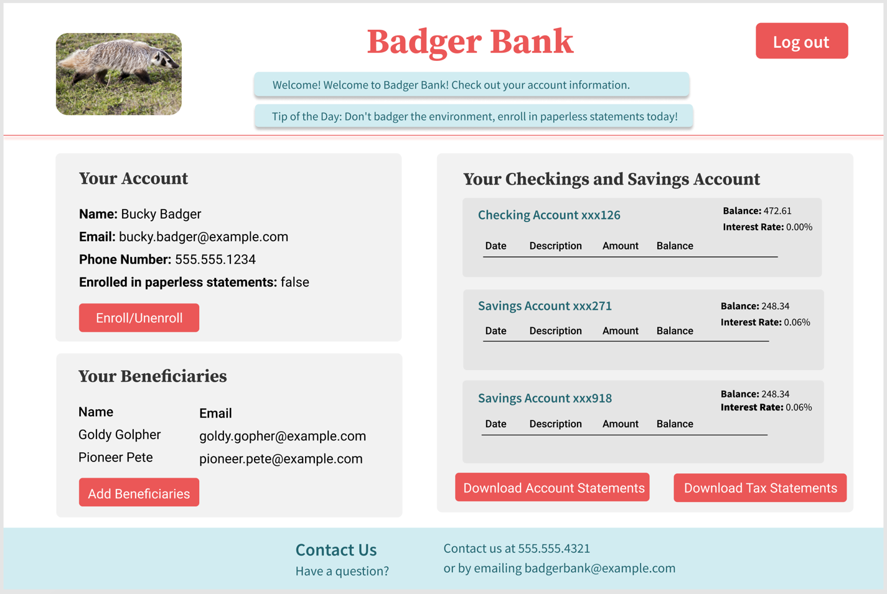

Account details here

contrast red and white -> bring attention

Analogous font and background color

Echo use of blue on top and bottom -> balance

Contrast colors, direct attention to the buttons

(0.2 Points) **Step 2. Specify color and type choices.** Finally, determine what color palette your redesign should follow. How many colors/shades will you use? Why will you use these colors? Keep design principles in mind when you are choosing colors. For example, using contrasting colors, you can create contrast and manage user attention. Additionally, determine what category of typeface and what font you will use, whether or not you will use multiple fonts on the page, and how you will parameterize each font. You may review the fonts in your computer’s fonts folder (on Windows, go to “My Computer > Control Panel > Fonts” and select “View > Details;” on the Mac use the Font Book app) or the [Google Fonts collection](https://fonts.google.com) to give you ideas and get familiar with available typefaces.

I will be primarily using red, gray and blue of 2 different shades, and the font color will be black, white, or blue. I choose red because this website is called “Badger Bank”, what color other than red could fit a badger? I use contrast coloring between red and blue to direct user’s attention to the name of this website and the alert information at the top. The red horizontal line is to divide space and separate the headings from the content, creating a sense of order.

Light gray will be the background color for the content, and light blue for alerts and the footer. Each account will be separated into darker gray blocks so that users can distinguish the boundaries of each account. Balance is achieved through having blue colors on both top and bottom of the web page. The contrast between the light gray/white background and red buttons direct user’s attention to the buttons, by which they would be able to interact with the application. Blue will be used for the account’s name so that it is separated out from other titles and headers. All squares will have rounded corners so that the whole design achieves unity in terms of the shape choices.

The font for the website name will be Source Serif Pro, and others for paragraphs will be the default Roboto. H1 and h2 headers will be serif since large font sizes draws attention and creates the focal point, so it is fit for being used as the headings. All the titles and table headers will be bold, whereas the information itself is of regular size. This is out of the need to separate the title from the information to guide users’ attention.

### **Part 3:** Implementation

(0.2 Points) **Step 1. Inspect component library elements.** In this step, you will inspect the [Bootstrap](https://getbootstrap.com/docs/4.5/getting-started/introduction/) component library to see how you can realize the layout, visual-element, and color/type choices you have made in the previous part using the component library. You are not expected to change the library components to exactly match your design choices, but to identify which component elements might best meet your design goals. Below, copy the design and the choices you generated in Part 2 and annotate them to describe which components from the library you will use to accomplish your design goals.

.btn-primary

.btn-lg

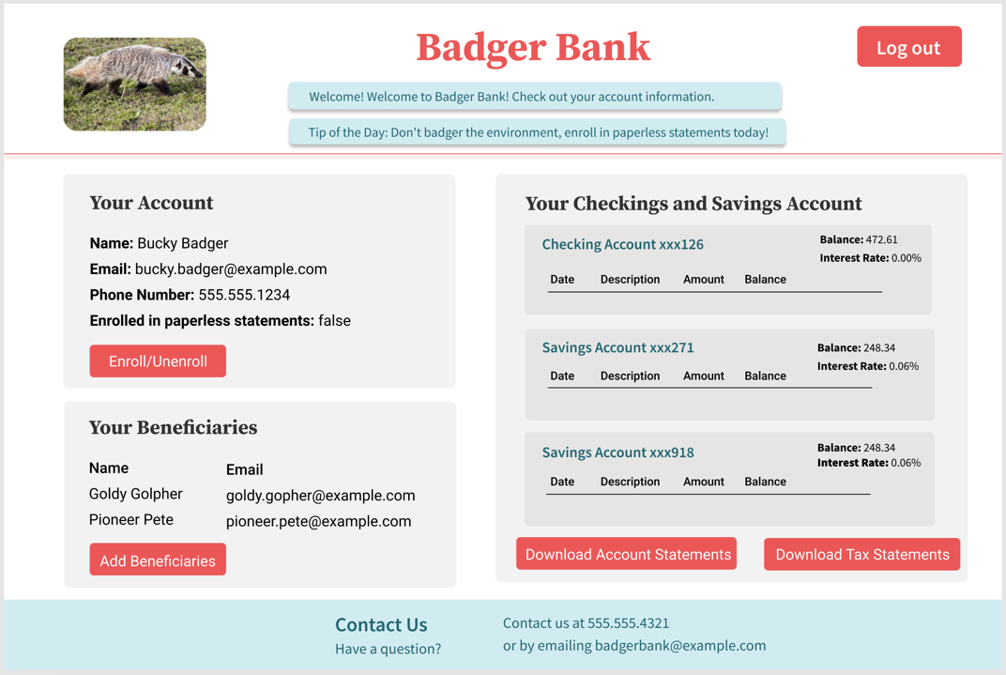

.table-bordered

.btn-secondary

.btn-secondary

.alert-info

(0.6 Points) **Step 2. Implement your redesign.** The last step of this part will involve implementing the layout and components you had identified in the previous step. You will include Bootstrap in your project and use it to implement your design. You do not have to implement new *functionality*; focus on implementing your *design*.

Your deliverable will be a completed version of this document, attached to the canvas assignment as a PDF, and the GitHub Classroom repository name and latest commit hash.

